ParkEase – Smart Parking Spot Finder
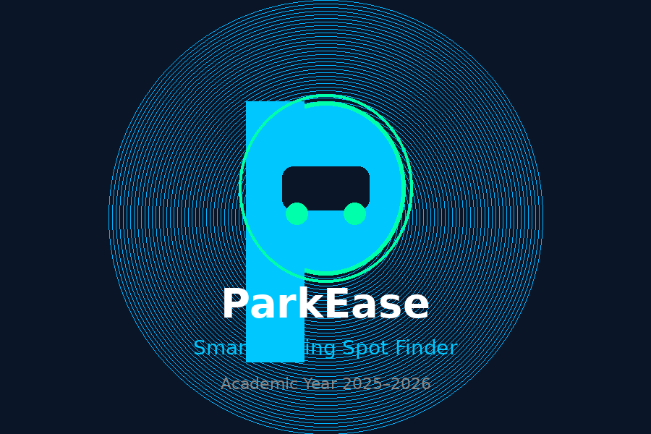
Project Plan Document

1. Introduction
ParkEase – Smart Parking Spot Finder is an intelligent parking management system designed to help drivers find, book, and manage parking spaces in real time through a digital web platform.
With increasing vehicle population in urban areas, finding a parking slot has become a major time-consuming problem. Drivers waste valuable time searching for vacant spots, causing traffic congestion and frustration. ParkEase solves this by providing a smart web-based system where users can view available slots, book them instantly, and manage their bookings easily.

2. Problem Statement
In urban and semi-urban areas, the increasing number of vehicles has created serious difficulty in finding available parking spaces. Drivers spend significant time searching for parking slots, leading to traffic congestion, fuel wastage, and user frustration.
Existing parking systems lack real-time monitoring and digital guidance, resulting in inefficient parking space utilization. There is no automated system to guide drivers to available slots, leading to unnecessary movement and delay.

The core problem is:
There is no automated, real-time parking guidance system to help drivers locate available parking spaces resulting in time wastage, fuel loss, traffic congestion, and inefficient parking management.
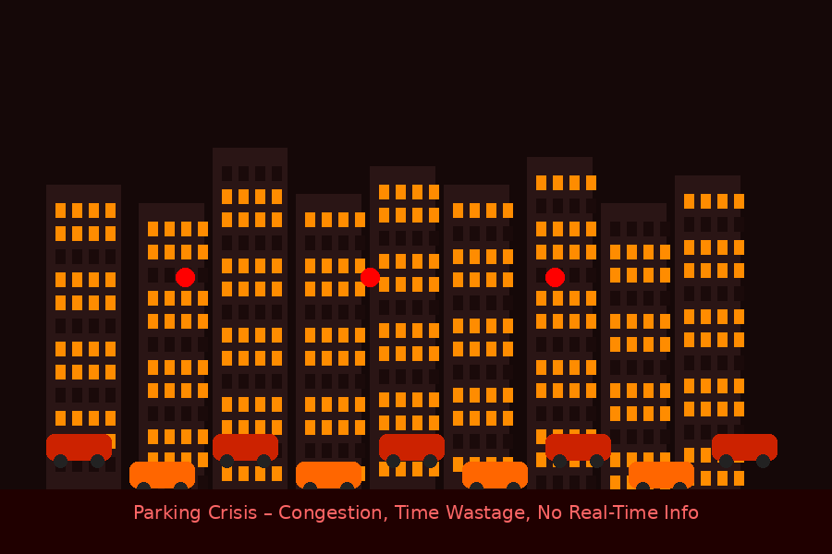

3. Objectives of the Project
The primary objectives of ParkEase are:
- To provide real-time parking slot availability to drivers
- To allow users to book and manage parking slots online
- To provide parking owners a dashboard to manage slots and track revenue
- To allow admins to monitor the full platform and all activities
- To reduce parking search time and minimize traffic congestion
- To build a user-friendly and role-based web application
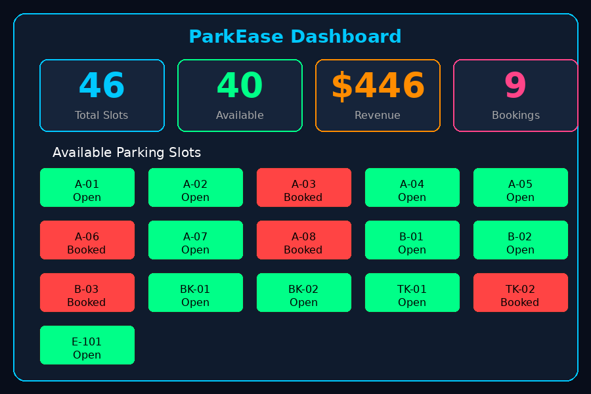

4. Scope of the Project
The scope of ParkEase focuses on developing a full-stack web application with three user roles User, Owner, and Admin providing real-time slot booking and parking management through a digital interface.

Current Scope:
- User registration and role-based login for Driver, Owner, and Admin
- Driver can view, search, filter, and book available parking slots
- Driver can view their booking history and cancel active bookings
- Owner can add and remove parking slots and track revenue
- Admin can monitor all users, owners, slots, and bookings on the platform
- Role-based dashboards showing real-time data from the backend

Future Scope:
- Online payment integration for slot booking
- GPS-based parking navigation and directions
- Mobile application development
- AI-based parking availability prediction

5. Technology Stack
- Frontend – HTML5, CSS3, JavaScript
- Backend – Java, Spring Boot, Spring Security
- Database – MySQL
- Authentication – JWT (JSON Web Token)
- Tools – VS Code, MySQL Workbench, Postman, GitHub
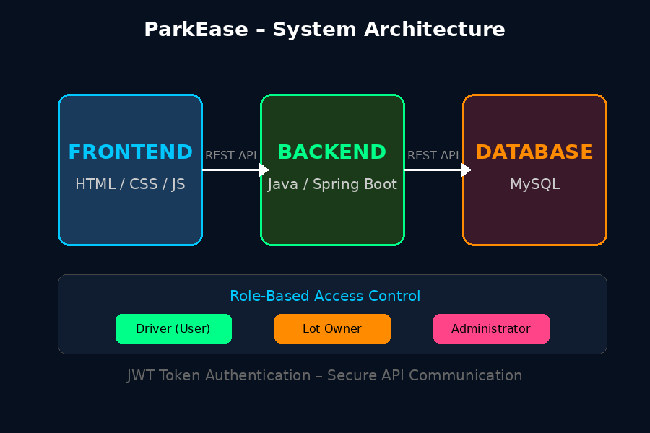

6. Modules in the Project

User Module (Driver)
- View all available parking slots with vehicle type filter (Car/Bike/Truck)
- Book a parking slot by selecting start and end time
- View booking history with status and cost
- Cancel an active booking

Owner Module
- Add new parking slots with slot number, vehicle type, and price per hour
- View all parking slots with current availability status (Available/Booked)
- Remove a parking slot
- View recent bookings and track total revenue earned

Admin Module
- View platform overview with total users, owners, slots, and bookings
- Monitor all registered users and parking owners
- View all parking slots and all booking records with status

Authentication Module
- Secure login and registration for all three roles
- JWT token based session management for secure API access
- Role-based access control for each dashboard

7. Project Approach
ParkEase was developed using a systematic and modular approach to ensure clarity, scalability, and practical implementation:
- Requirement Analysis – Identified system requirements including user roles, dashboard features, and API structure.
- System Design – Designed frontend and backend architecture connected through REST APIs with JWT authentication.
- Database Design – Created MySQL schema with tables for users, parking areas, parking slots, and bookings.
- Backend Development – Built Spring Boot REST APIs for authentication, slot management, booking, and admin monitoring.
- Frontend Development – Developed all dashboard pages using HTML, CSS, and JavaScript with live API integration.
- Testing and Fixing – Tested all features end-to-end and resolved issues found during development and integration.
- Documentation – Prepared individual contribution reports and project plan document for submission.

8. Team Members and Roles
ParkEase is developed by a four-member team, with each member contributing to a specific area:
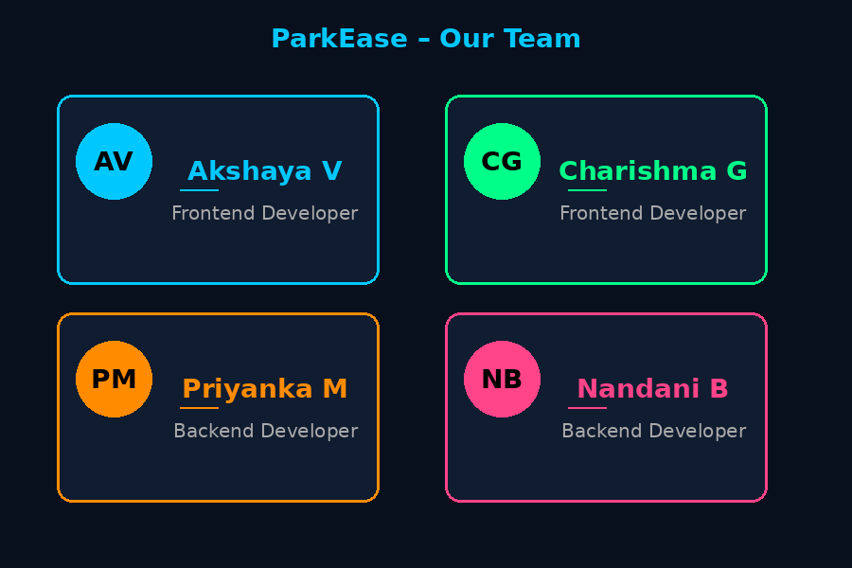

1. Akshaya V – Frontend Developer
- Designed and built all UI pages: Landing Page, User Dashboard, Owner Dashboard.
- Implemented slot booking, filtering, and bookings management features on the frontend
- Worked on page design, layout consistency, and user experience improvements
- Tested and fixed frontend issues including slot display, bookings table, and revenue calculation

2. Charishma Gangireddy – Frontend Developer
- Developed and styled UI components across the application
- Contributed to Admin Dashboard UI layout and design
- Connected all frontend pages to backend REST APIs with JWT authentication.
- Collaborated with backend team for API integration

3. Priyanka Murlidharan – Backend Developer
- Developed complete backend REST APIs for User and Admin modules including authentication using Spring Security and JWT tokens
- Built booking, slot management, profile, and password change service logic with full CRUD operations in Spring Boot
- Designed and implemented Admin dashboard backend with stats, user/owner management APIs, services, controllers, and DTOs
- Integrated AI chatbot using Groq LLaMA API for intelligent parking assistance

4. Nandani Baghel – Backend Developer
- Developed secure backend services for booking, slot management, user profile, and password management with full CRUD operations using Spring Boot
- Implemented JWT-based authentication and authorization, including token generation, validation, role-based access control, and secured API endpoints
- Designed and structured a robust MySQL database schema with optimized tables, relationships, and indexing
- Built and integrated scalable backend APIs, services, and DTOs to support dashboard and parking management functionalities and Managed GitHub repository

9. Applications of ParkEase
ParkEase can be successfully deployed in various real-world environments where efficient parking management is essential:
- Shopping malls and commercial complexes
- Hospitals and medical centers
- Educational institutions and college campuses
- Office buildings and IT parks
- Airports and railway stations
- Smart city parking zones and public spaces
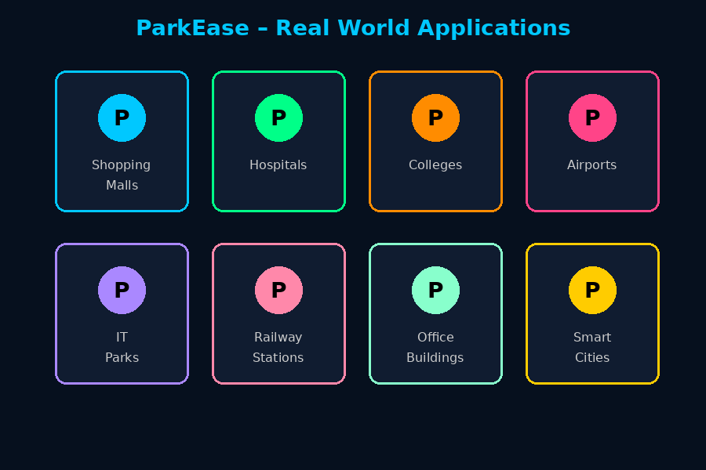

10. Conclusion
ParkEase – Smart Parking Spot Finder provides a practical, user-friendly, and technically robust solution to the modern urban parking problem. By combining a well-designed web frontend with a secure Spring Boot backend and MySQL database, the system enables real-time parking slot management and booking for all three user roles — Driver, Owner, and Administrator.
This project demonstrates effective teamwork, full-stack development skills, and practical problem-solving. It serves as a strong foundation for a smart parking system that can be expanded and deployed in real-world environments.

